

|  |  |  |  |  |  |
| --- | --- | --- | --- | --- | --- |
|  |  | portal.lemlewolff.net  Updated: 09/03/2024 | |  | |
|  |  |  | | |  |
|  |  | User Manual  Lemle & Wolff Reporting Portal | | |  |
|  |  | |  | | |

**Lemle Wolff Portal Website**: <https://portal.lemlewolff.net>

**Yardi SQL Portal (Client Central):** [https://clientcentral.yardi.com](https://clientcentral.yardi.com/)

**Sortly Inventory Website:** [app.sortly.com/login](https://app.sortly.com/login)

Table of Contents

Overview 3

Schedule 3

Accessing the Portal 3

Accessing the Yardi ySQL Website 4

Exporting Data from Yardi Website (5 downloads) 5

Download Sortly Data File 6

Download ADP Timesheet File 8

Importing Data Files into the Portal 8

Updating Physical Inventory Counts 10

Updating Inventory Counts – Importing by File 10

Updating Inventory Counts – Using the Edit Screen 11

Reports 12

Resolving Blocked Macros 13

On a single file 13

Unblock all files delivered from our Portal 14

# Overview

In order to produce the **Work Order Analysis Report** and the **Daily Inventory Report** certain data needs to be imported into the Portal Website first. The following extracts need to be first created and downloaded from the various locations and then imported into the Portal:

1. ADP TimeSheet Report (from the ADP website)
2. Yardi Data (5 extracts)
3. Sortly Inventory Data (from the Sortly website)

Once these are imported into the Portal you can run the reports for any given date range (as long as that date range has been loaded in the above extracts)

There is no harm in loading files more than once.

## Schedule

This whole export/import process should be run **every Tuesday morning and on the 1st of each month**. It looks involved here in the instructions, but it is a pretty straight forward process once you run through it a couple of times.

# Accessing the Portal

The Portal (Portal.Lemlewolff.net) is where you will upload data and download the final reports.

To access the Portal, visit the website <https://portal.lemlewolff.net>. You must have been given an account in advance. If you do not have credentials, contact John Rebuth.

To access the Portal:

1. Go to [www.lemlewolff.net](http://www.lemlewolff.net)
2. Login with your email address and your given password
3. From there you will want to either go to **Importing** data or **Running and Downloading** **Reports.** See the other sections here for more details.
4. If you are needing to import data then click on the Import Data link. Keep this window open since you will need to refer to it when downloading the Yardi SQL files in the next section.

# Accessing the Yardi ySQL Website

The Yardi ySQL Interface is a Web portal where you can run SQL queries and get results from the live data. The process of updating our database is to run 5 different scripts, save the resulting CSV files locally on your computer, and then ploading them into the Lemle Wolff Portal.

If you cannot log into the ySQL website, contact a supervisor at Lemle & Wolff.

Follow these steps to access the ySQL screen and set it up in order to properly run the queries. **Be sure to follow all steps** – especially setting the number of rows to return:

1. Go to [clientcentral.yardi.com](https://clientcentral.yardi.com/)
2. Enter your email address, press **Enter**
3. On the next screen you will be asked to enter your email address and password, Enter both and click **LOGIN**
4. Choose ySQL from the Cloud menu

1. Choose **ASP1 – rbthm_live** database shown here:

1. Change the result limit to **Unlimited** **(IMPORTANT!)**

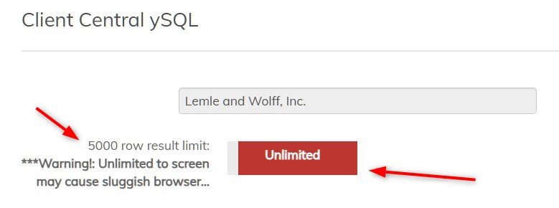

1. Now you are ready to run SQL Scripts and export data. Follow the steps in the **Exporting Data from Yardi Website** section.

# Exporting Data from Yardi Website (5 downloads)

The first step is to run and download data from Yardi. Follow these steps to pull all the data needed to run all reports.

1. In the Lemle Wolff Portal click the first link listed in the Import Data page

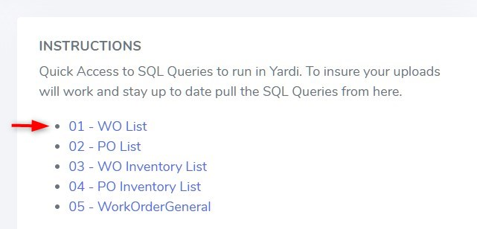

1. In the window that opens do a Select All (Ctrl-A) and Copy (Ctrl-C)
2. Go to the Yardi ySQL window and Paste the text into the SQL Editor and click **Submit to CSV**

1. You’ll see the Running SQL button spinning…

1. When the processing is done you will be prompted to download the CSV file. Save it somewhere on your local computer to access it later.
   1. TIP: Name the file starting with a number corresponding to the script number below. For example:
   2. Name it with “1” if you were running this file:

1. Click on the next file in the Lemle Wolff Portal:

1. Follow the steps above starting from step 2 until you do this same process for all 5 files.
2. At the end you should have 5 CSV files saved, numbered 1 to 5.

*Continue with the next section to download the Sortly File*

# Download Sortly Data File

Another file we need to retrieve and import into the Portal Data is from the Sortly website. This provides inventory data. Follow these steps to download and save the file locally on your computer:

1. Log in at [app.sortly.com/login](https://app.sortly.com/login)
   1. If you don’t have a Sortly account contact John Rebuth
2. Choose **Reports** >> **Inventory Summary**  
   A screenshot of a computer

   Description automatically generated
3. Click the **Export** button in the upper right corner
4. Click on the **Any Folder** button so we can filter only the folders we want
5. In the Filter screen click the **All Items** checkbox to UNCHECK it. This will uncheck all the sub-folders.
6. Click and place checks in the **1-Inventory** checkbox, and the **4-Today’s Work Orders** checkbox so that only those are checked off.  
   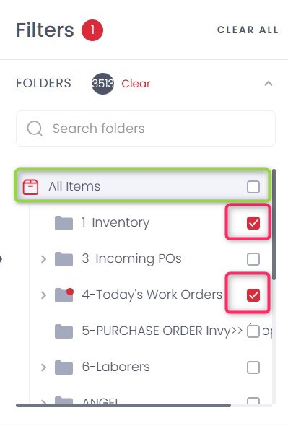
7. Click the **Apply** button
8. Click the **Export** button
9. In the **Export Settings** screen:
   1. Turn on **Export as .xlsx (Excel)**:

* 1. Optionally uncheck the following to make the export file smaller:
     1. All **8 Photo** columns (Photo1 to Photo8) and all **4 Barcode** columns

1. Click the **Export** button
2. Save the file locally on your computer. You will import this file into the Portal in the later sections.

*Continue to* ***Download the ADP Timesheet file****.*

# Download ADP Timesheet File

Currently only John Rebuth has access to this file so he will instead provide it to you. Save it locally on your computer.

*Continue on to* ***Importing Data Files into the Portal***

# Importing Data Files into the Portal

You should have 7 files prepared from the previous sections to import.

* 1. Yardi ySQL File 1 (Work Orders for the WO Analysis Report)
  2. Yardi ySQL File 2 (Purchase Orders for the WO Analysis Report)
  3. Yardi ySQL File 3 (Work Orders for the Inventory Report)
  4. Yardi ySQL File 4 (Purchase Orders for the Inventory Report)
  5. Yardi ySQL File 5 (General Work Order Details)
  6. Sortly XLSX File
  7. ADP TimeSheet File

You don’t need to import all the files at once. You can import them individually at any time and bring in the others later. Just make sure all the files are imported before running the reports.

Follow these steps – you do not need to import files in any particular order:

1. Log into the Portal at <https://portal.lemlewolff.net>
   1. NOTE: It is advisable to enter “https” to access the website. This will turn on added security.
2. Click on the **Import Data** menu item

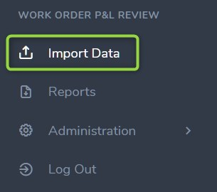

1. At the top of the page there is a section indicating the date ranges for each of the files that have been loaded. This is to help you see which files have been loaded and which still may need to be loaded before running reports.
2. In the **File Selection and Import** section choose the file you wish to import from the Drop-Down:

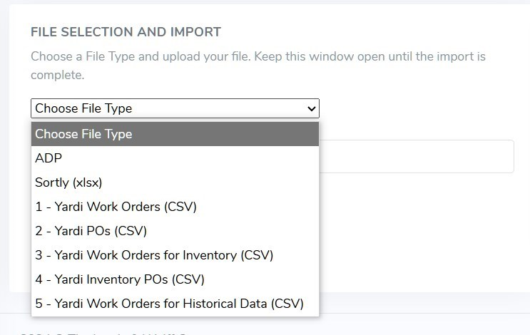

1. In the **Choose File** box click the **Choose File** button and select the appropriate file from your local computer.
2. Click Upload
3. When the upload is complete you will see a green **Success!** message
   1. **IMPORTANT**: If you notice that a file loads and says, “**Success! 5000 row(s) successfully processed.**”, this could indicate a problem. If it is exactly **5000** rows it usually indicates that the “Unlimited” option was not selected in Yardi when the file was exported, and it only exported 5000 records. In this case return to the Yardi portal and export the file again.
4. Continue to the next file you wish to upload until all files are successfully uploaded

If there are errors in uploading files it is usually because the formatting of the file is off. The error message should give you some ideas on where the problem is.

# Updating Physical Inventory Counts

When Physical Counts are done at Lemle they can be set in our Portal by two methods:

1. Uploading a file that has all the items and physical counts (as well as the “As Of Date”)
2. Editing the data using the Inventory Counts Edit screen in the Portal

When you set a physical Count for a specific date (As Of Date) our inventory reporting will use this count starting at that date.

Use the File Import option when loading a large number of item counts. If you upload the same data with the same “As Of Date” the previous data will be overwritten.

Inventory counts are stored in the Portal database table: **tblPhysicalInventory**

## Updating Inventory Counts – Importing by File

Use the Import File methos when you have a large number of items to import or update. Here are the steps:

1. Create an Excel spreadsheet with the following columns (use the **Exact** names for the columns):
   1. **AsOfDate**: The “As of Date” for the inventory count for each item
   2. **Code**: The Item Code (ie, 10-00200)
   3. **Quantity**: The number of items counted
   4. **Description**: (Optional) The text description of the item. If not included we will use the last description of the item found in the database. Important: Include this column even if you don’t use it – just leave all cells blank
   5. Example:  
       A screenshot of a computer

      Description automatically generated
2. Go to the IMPORT DATA page on the Portal
3. Choose “Physical Count Import (xlsx) as the File Selection and click the **Upload** button:  
   A screenshot of a computer

   Description automatically generated

NOTES:

* You can upload multiple files and if you upload duplicate information with the same “AsOfDate” the last file uploaded will be used. It is safe to upload the same file multiple times.
* To change all the **AsOfDates** for a batch upload and there are too many to edit using the Edit screen explained below, this will need to be done on the back-end at this point. Contact support (Vincent). Otherwise, this can be done by using the Edit screen and editing one at a time.

You can use the Edit Screen explained in the next section to validate that your uploads succeeded

## Updating Inventory Counts – Using the Edit Screen

To edit specific rows of data for our Inventory Counts you can use the Edit screen here:

1. Go to the Portal >> Administration >> Inventory Counts
2. To find specific rows of data use the Filter section and click “Filter”. You can enter a Date and/or all or part of an Item Code.   
   A screenshot of a computer

   Description automatically generated
3. Edit specific rows by changing the data and then click on **SAVE**  
   A screenshot of a computer

   Description automatically generated
4. Click on the **Delete** button to completely remove the record
5. Click on the “**+ Add New Record**” to add records. Follow the same data rules for each field as defined above with the File Import and click the **Add Record** button.

# Reports

To download reports:

1. Click on the **Reports** menu item  
   A screenshot of a report

   Description automatically generated
2. For each report enter a **Start Date** and an **End Date**
   1. NOTE that the Start Date is inclusive, and the End Date is NOT inclusive. So an end date of 9/1 will give you all data through and including 8/31, bit not 9/1.
3. Click on the appropriate Download button
4. The report will be processed and can take a few minutes. When it is done it will display a link below the download button with the report name.
5. Click on the link to download and save the report.  
   A screenshot of a report

   Description automatically generated

# Resolving Blocked Macros

If you receive this error in the downloaded spreadsheets:

You can unblock macros in a few ways:

## On a single file

After you download and save the file you can unblock macros by modifying the properties of the file as follows:

1. Open Windows File Explorer and go to the folder where you saved the file.
2. Right-click the file and choose **Properties**from the context menu.
3. At the bottom of the **General**tab, select the **Unblock**checkbox and select **OK**.

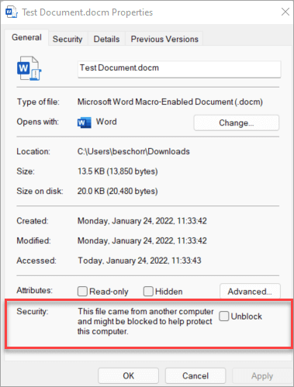

## Unblock all files delivered from our Portal

You can set the Portal Site as a trusted site in Windows so macros from the site won’t be checked.

1. Tap the start button or Windows key and type .
2. Select **Internet Options** from the search results and the **Internet Properties** dialog box appears.
3. On the **Security**tab, select **Trusted Sites**, and then select **Sites**.
4. Type the URL **https://portal.lemlewolff.net**, and then select **Add**.
5. Select **Close,**and then **OK**.  
     
   A screenshot of a computer

   Description automatically generated

**NOTE**: For this to work you must always access the portal using HTTPS. Use this URL: <https://portal.lemlewolff.net>. Not including the “s” in https will keep the file unsecure and blocked.